Print-on-Demand Name Tags
Print-on-demand name tags are an easy and economical way to identify university personnel or event attendees. The templates allow you to print name tags as needed. Learn more about print-on-demand name tags on the UB Brand website.

PEEL-AND-STICK TEMPLATE:
Microsoft Word peel-and-stick templates were designed to be printed on Avery White Adhesive Name Badge label paper (Product Number 5395). Purchasing proper stock paper is recommended for best results.

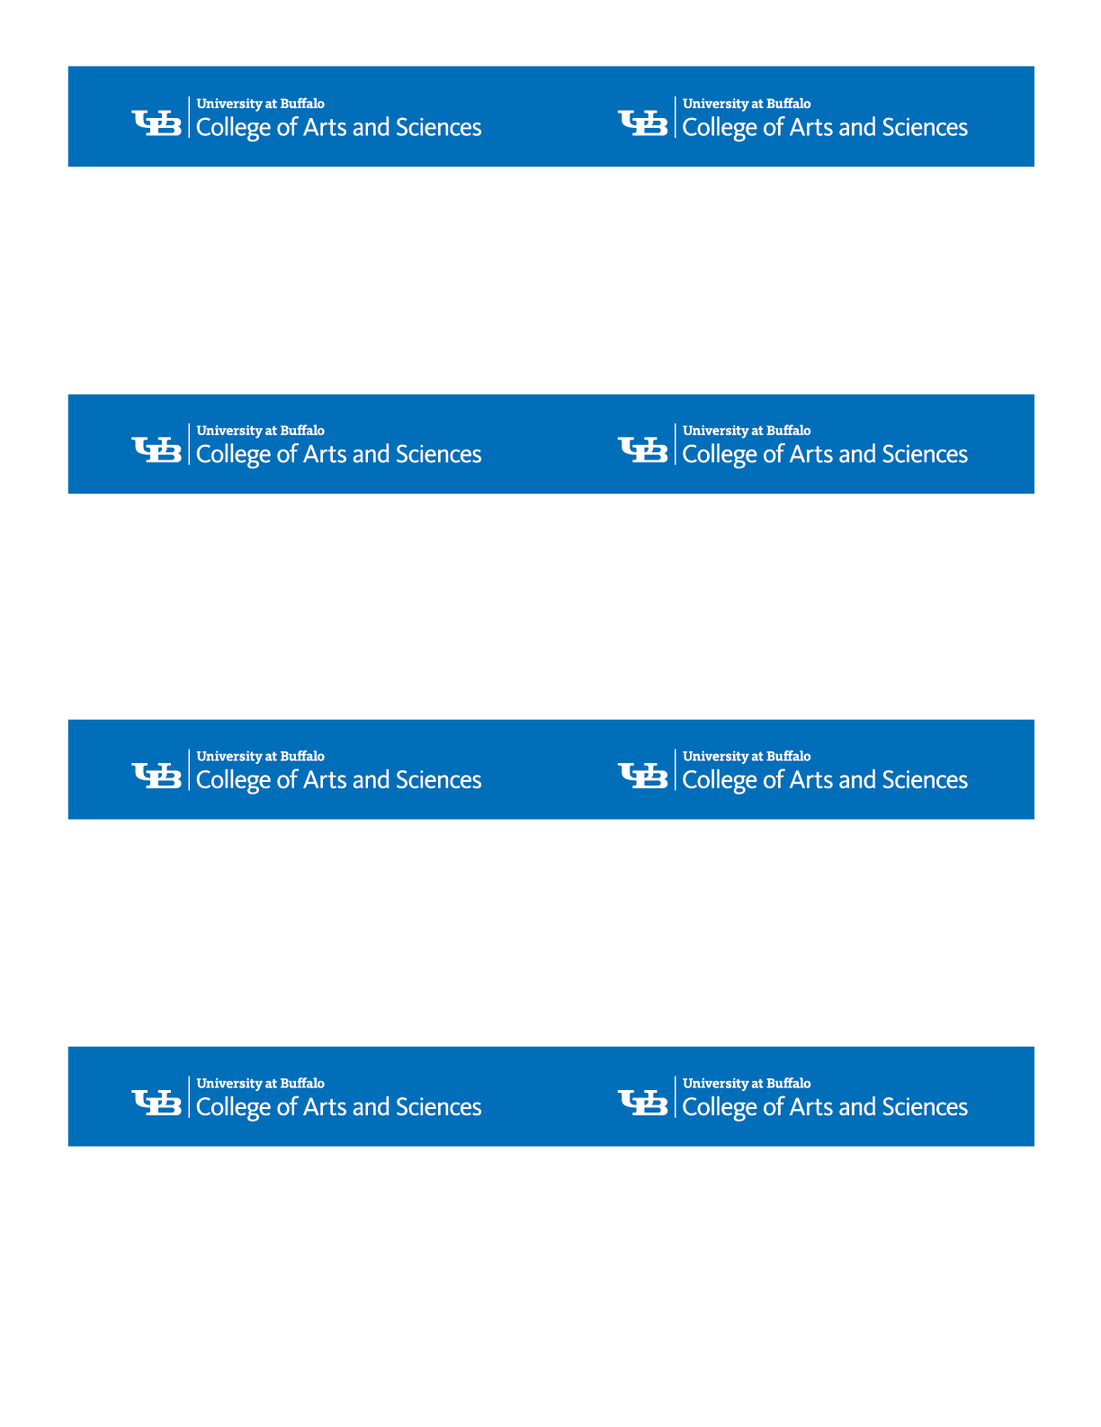
First Name Last Name
Optional Position Line One
Optional Position Line Two
Optional Department Line One
Optional Department Line Two

First Name Last Name
Optional Position Line One
Optional Position Line Two
Optional Department Line One
Optional Department Line Two

First Name Last Name
Optional Position Line One
Optional Position Line Two
Optional Department Line One
Optional Department Line Two

First Name Last Name
Optional Position Line One
Optional Position Line Two
Optional Department Line One
Optional Department Line Two

First Name Last Name
Optional Position Line One
Optional Position Line Two
Optional Department Line One
Optional Department Line Two

First Name Last Name
Optional Position Line One
Optional Position Line Two
Optional Department Line One
Optional Department Line Two

First Name Last Name
Optional Position Line One
Optional Position Line Two
Optional Department Line One
Optional Department Line Two

First Name Last Name
Optional Position Line One
Optional Position Line Two
Optional Department Line One
Optional Department Line Two

